**Isaiah Chapter 41 – Part 1**

The point of this study is not to race through the four Servant Songs and check them off our list. No. It is to demonstrate that Jesus can be found to fulfill Old Testament prophecy. The Old Testament Scriptures are written about Jesus. As a reminder:

John 1:45 Philip *found Nathanael and *said to him, “We have found Him of whom Moses in the Law and also the Prophets wrote—Jesus of Nazareth, the son of Joseph.”

Luke 24:27 Then beginning with Moses and with all the prophets, He (Jesus) explained to them the things concerning Himself in all the Scriptures.

Matthew 5:17 “Do not think that I came to abolish the Law or the Prophets; I did not come to abolish but to fulfill.

Job says:

Job 14:4 “Who can make the clean out of the unclean? No one!

But he was wrong—Jesus Christ can and does with every new believer. This is encapsulated in the history of the Bible as Herman has illustrated (from His series on Revelation):

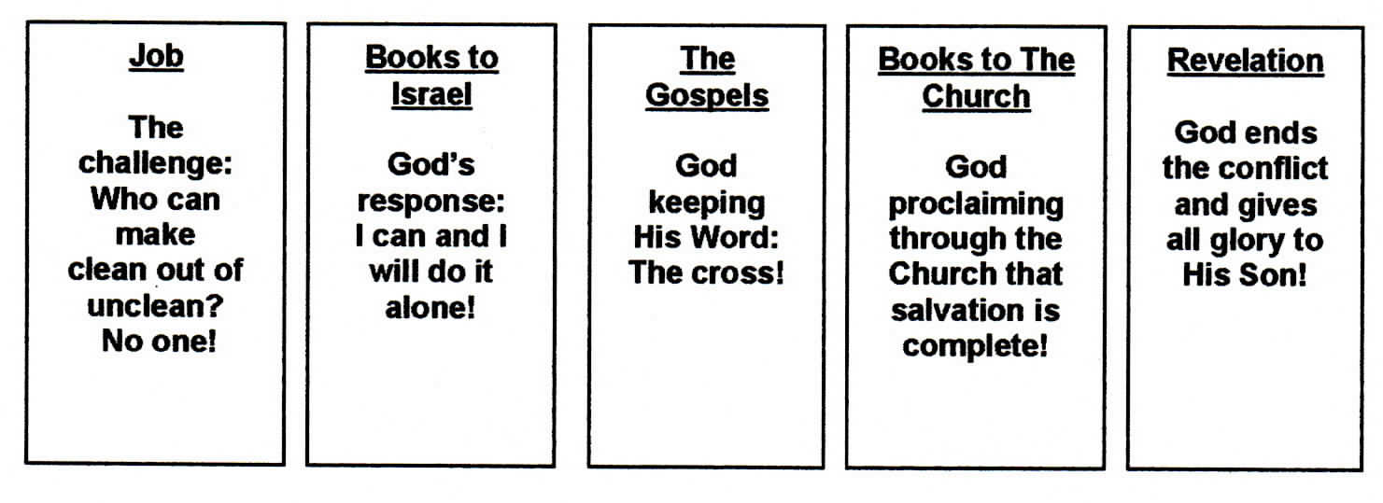

First, let us review some concepts which are important to understand when studying the book of Isaiah: dispensations, angelic conflict and prophecy.

**Dispensations**.

“Dispensations have to do with God's governing or administrating human history through a sequence of divinely directed administrations marked by distinct periods of time as He works out His plan to destroy sin and evil. It is an understanding of the meaning and purpose of history; but when you think of the words 'purpose of history,' that means history is going somewhere.” (Dean)

The word in the new testament that is used by Paul is *oikonomos*. It literally means “house rule.” Each dispensation is characterized by a set of God-given rules governing man and nature for the outworking of God’s Plan.

The Jews lived under the Mosaic Law. Christians live in a different dispensation we call the Church Age. The Jews are looking forward to the Millennial Kingdom of the Messiah. In between is the conclusion of the Jewish Dispensation we call the Tribulation. The last half of that 7-year period is called Jacob’s Troubles. It will contain suffering unseen previously in history.

Isaiah lived in the Jewish Age under the Mosaic Law. But, he looked forward to the Millennial reign of the king in the kingdom.

**Prophecy**.

I covered this in five lessons last year. Below is information from Robby Dean which I have put into a slide.

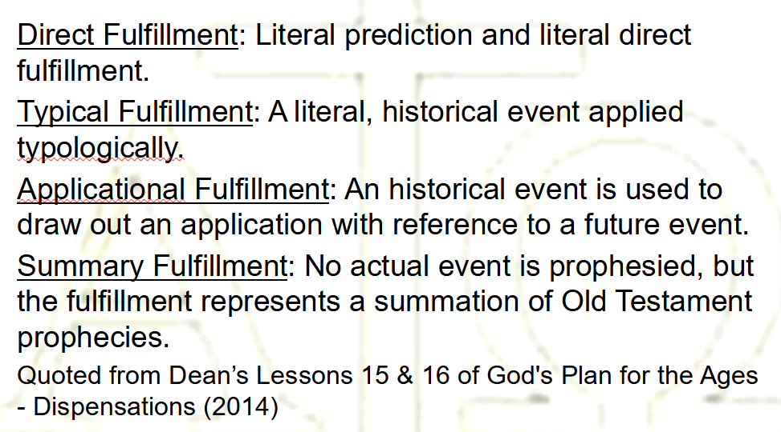

From Robby Dean God’s Plan of the Ages Lesson 16

**Angelic Conflict**. I have not taught a doctrine of the Angelic Conflict. But, Herman has. So I will take you to Herman’s lessons on the “Invisible Warfare” which are part of his study of the book of Daniel. Please take note that I am excerpting items from those lessons. To review his lessons in depth, go to the study of Daniel on the http://www.springvalleybiblechurch.org/Daniel.htm website and then to lessons 39-43. Here are notes from his outline:

1. One Will.

(Before Creation) One Will—God’s: God the only one in existence.

1. Triune God

We have the Triune God: God the Father, God the Son, God the Holy Spirit In One.

1. Creation of Angels—Two Wills.

God Creates Angels. Enter: Two Wills.

1. Conflict

We have God—His will; then we have angels—two wills. Now Conflict is introduced by the highest angels using their will against the Will of God.

1. Result of the Conflict

The fall of super creatures…angels, establishing the origin of Un-Righteousness and of Evil, and sin. But God did not create evil, God did not create Un-Righteousness, or Evil.

1. The Challenge

Satan, protest: Since the creature’s unrighteousness is the basis of condemnation, how can a Righteous God save anyone?

1. Resolving The Angelic Conflict

A. Not having the Perfect Righteousness of God, all the fallen angels, including Satan, were sentenced to the Lake of Fire. This sentence took place in Eternity-Past Matthew 25: 41.

B. It is the saving of creatures that Satan challenges.

C. This set up the declaration of the Love of God (Divine Love) in sending His Son.

D. The creation of mankind was to resolve The Angelic Conflict. If even one created being lower than angels simply believes in the one God sends, this reveals to angels the fairness of God in condemning angels or mankind.

1. The Angelic Realm

There are two categories of the higher creatures or angels revealed in the Bible.

A. Fallen or unsaved angels known as demons, who follow Satan. 1 Timothy 4:1; Jude 1:6; 1 Corinthians 10:20-21; Mark 5:2.

B. Saved angels. 1 Timothy 5:21; Mark 8:3.

1. The Trial

God responds to this challenge by creating a creature lower and inferior to angels, called mankind, and placed them on the only planet designed for habitation—planet earth. Hebrews 2:7 Hebrews 1 and 2 are more in depth study of angels and the Angelic Conflict.

Lucifer was created perfect. He was a “covering Cherub.” One Bible teacher, perhaps R. B. Thieme Jr., suggested that he was a guardian of God’s righteousness. As such his focus was on God’s character, his righteousness in particular. Hence, when Satan finds unrighteousness in God’s creatures like believers today, he is quick to point this out to God. Satan is our adversary in court. But Jesus is quick to counter. “I took care of that on the cross.” Or in some cases, God disciplines a believer. But that believer does not lose salvation. From Satan’s perspective, How can a righteous God save an unrighteous human being? In other words, in Job’s words, “Who can make the clean out of the unclean? No one!” Before the cross, perhaps Satan did not understand the Scriptures explaining what the Savior had to do to accomplish this task. Now he does. Angels learn of the character of God from the outworking of God’s plan through humankind.

One more item from Herman’s study of the book of Revelation. The Bible deals with both activities in heaven and activities on earth. As Herman explained, the activities in heaven have an impact on what happens on earth. Here in Isaiah we have activities in heaven that have an effect on earth. Now Herman mapped out these activities during the Tribulation in the book of Revelation:

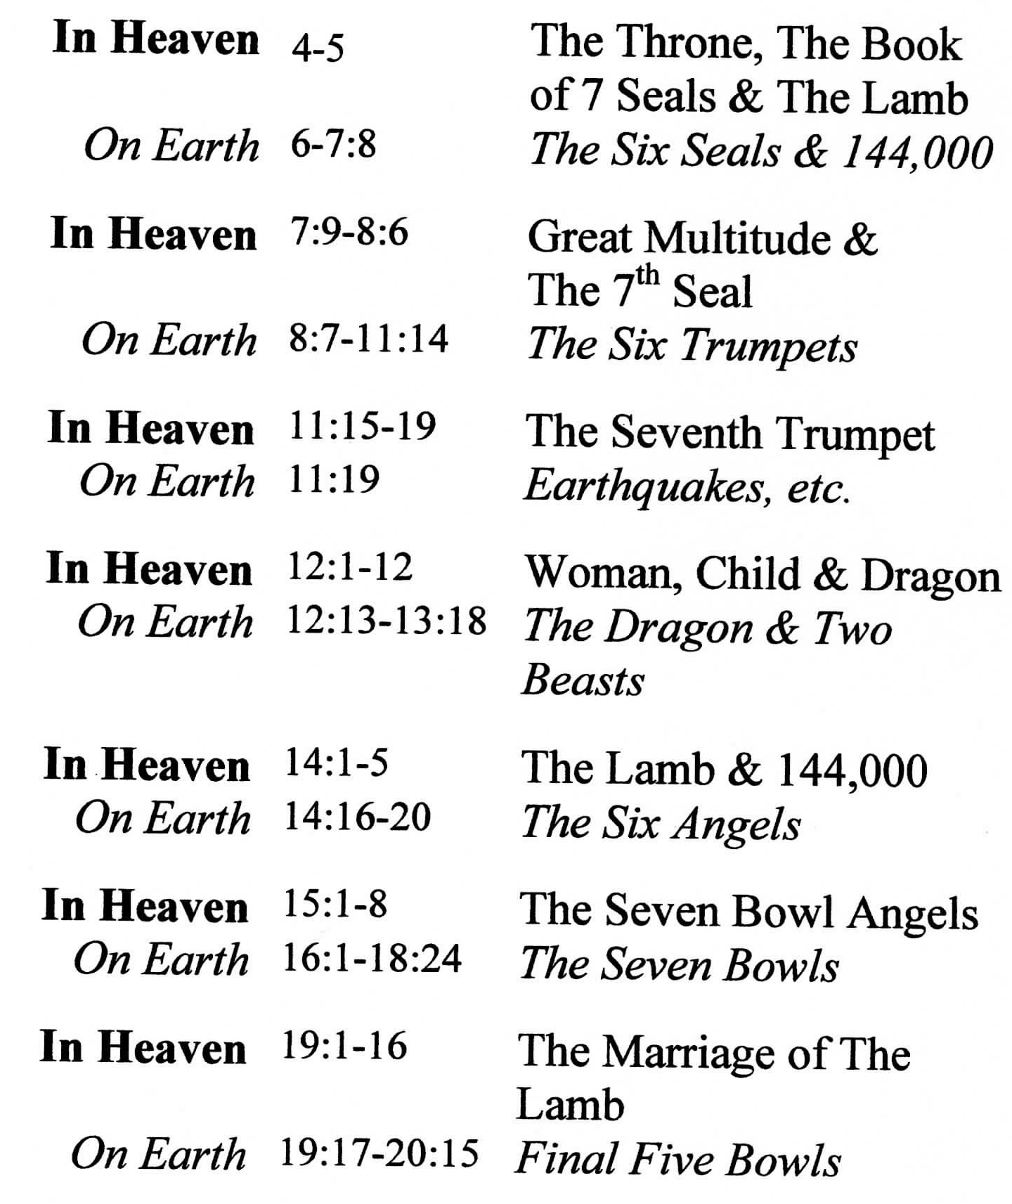

Note the alternation: In Heaven and On Earth.

Here is Isaiah chapters 40-41 and beyond we are in the divine council room with the heavenly host in attendance. Demons representing Satan’s cosmos diabolicus including specific earthly geographic areas are in attendance. Isaiah is representing Israel. It is because of Isaiah’s attendance, however God effected this, that we have this section of the book of Isaiah. The context and vocabulary are laden with court/legal terms. The text does not have to say we are in a courtroom standing next to Isaiah, the vocabulary and flow of thought indicates that. Remember, the Hebrews did not think or write like today’s western world. They were focused on descriptions from sight and sound. From the vocabulary and the descriptions we infer we are looking through Isaiah’s eyes seeing heavenly actions.

Let’s start with a tentative outline of part of Isaiah chapter 41:

1. Call Court to Order (vss 1-2)

2. God’s Argument for Himself (vss 3-4)

2. God’s Argument Against the Adversaries (vss 5-6)

3. God’s Argument for His Client (Israel) (vss 7-10)

Isaiah 41:1 “Coastlands, listen to Me in silence, And let the peoples gain new strength; Let them come forward, then let them speak; Let us come together for judgment.

**Coastlands**. This is not the first word in the Hebrew, but it is the one that when read would raise an immediate question. Who or what are the “coastlands.” Is this a reference to sons of Israel or to someone else?

From Thomas Constable:

The "coastlands" were the farthest reaches of the Gentile world: nations that bordered the seas, the ends of the earth then known, not just islands as such (cf. Jer. 25:22). By summoning them to be silent, the LORD was appealing to all the Gentiles to listen to Him (cf. 1:2). In chapter 40 Isaiah spoke of God in the third person, but in this chapter God Himself speaks. Note this oscillation in the chapters that follow as well. By heeding Yahweh the Israelites would gain new strength, the same strength that was Israel's privilege (cf. 40:31). The Gentiles were to be fellow heirs with Israel (cf. 19:24-25; 27:13). But before that could happen, they had to meet with the LORD and arrive at a decision (cf. Job. 38:3).

He then quotes from Delitzsch’s commentary on Isaiah page 157.

“The words are addressed to the whole of the heathen world, and first of all to the inhabitants of the western islands and coasts. This was the expression commonly employed in the Old Testament to designate the continent of Europe, the solid ground of which is so deeply cut, and so broken up, by seas and lakes, that it looks as if it were about to resolve itself into nothing but islands and peninsulas.”

This is all very fine, but let us step back and look at the scene in heaven. Are the nations of the world present there in heaven? No. Are they represented there. In a way, yes. Let us first look at the cosmos diabolicus.

First cosmos diabolicus from L. S. Chafer. I originally thought this was a term from R. B. Thieme. But obviously Thieme picked this up from L. S. Chafer:

“The *cosmos* is a vast order or system that Satan has promoted, which conforms to his ideals, aims, and methods. It is civilization now functioning apart from God—a civilization in which none of its promoters really expect God to share, who assign to God no consideration in respect to their projects; nor do they ascribe any causativity to Him. This system embraces its godless governments, conflicts, armaments, jealousies, its education, culture, religions of morality, and pride. It is that sphere in which man lives. It is what he sees, what he employs. To the uncounted multitude it is all they ever know so long as they live on this earth. It is properly styled *the satanic system*, which phrase is in many instances a justified interpretation of the so-meaningful word, *cosmos*. It is literally a *cosmos diabolicus*.” (Systematic Theology, Volume 2, p77-78).

Herman explained some of this when he taught the book of Daniel. In particular, Daniel 10:13 when the angel Gabriel told Daniel why he was delayed in answering Daniels prayer.

Daniel 10:10 Then behold, a hand touched me and set me trembling on my hands and knees.

Daniel 10:11 He said to me, “O Daniel, man of high esteem, understand the words that I am about to tell you and stand upright, for I have now been sent to you.” And when he had spoken this word to me, I stood up trembling.

Daniel 10:12 Then he said to me, “Do not be afraid, Daniel, for from the first day that you set your heart on understanding this and on humbling yourself before your God, your words were heard, and I have come in response to your words.

Daniel 10:13 But the prince of the kingdom of Persia was withstanding me for twenty-one days; then behold, Michael, one of the chief princes, came to help me, for I had been left there with the kings of Persia.

The question posed by Herman was, “Who is this prince of Persia?”

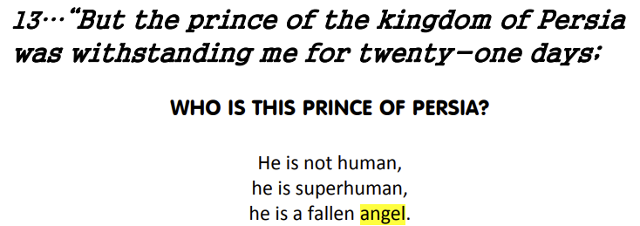

Fallen angel. Part of Satan’s cosmos diabolicus.

We know that from time to time there is a convocation in heaven at which the “sons of God” and Satan and perhaps his evil retinue attend.

Job 1:6 Now there was a day when the sons of God came to present themselves before the Lord, and Satan also came among them.

So, knowing that there are demonic rulers for nations within Satan’s cosmos diabolicus, then at this trial scene in Isaiah, it is possible that when the text references God talking to various nations, he is addressing these demonic rulers and by proxy, Satan himself. Satan has fallen angels assigned to the nations just as God has angels assigned to implement His will concerning the nations. Fallen angels and saved angels in opposition to one another: the angelic conflict.

It doesn’t make a lot of sense for God to speak to heathen nations of men directly in heaven. They are not there to hear. But the cosmos diabolicus representatives for those nations are there at a divine convocation. Isaiah is there by some means that God provided so that the nation of Israel would get the message. And as a result we have this message.

**Listen to me**. These are the first words in the Hebrew. The verb means to be silent but in the context it can mean listen or be attentive. In this context, it is almost like, when a judge enters the courtroom and the court is called to order. Here is a commentators explanation (Goldingay): “...the clause suggests a confrontation between two parties who are already standing in court in each other’s presence rather than a summons from a superior to an inferior. Yhwh challenges the nations to provide evidence that they are more than ‘dust rising’ (40.15).” Provide evidence.

**And let the peoples gain new strength**. Context. Some would say this is a reference back to the previous chapter “...Yet those who wait for the Lord Will gain new strength.” However, if this is the beginning of court proceedings, then strength may refer to the strength of the case against God. This reminds me of a scene from “Law and Order.” Jack McCoy, an assistant district attorney, says to the police detectives “You don’t have a case. Bring me some evidence before I can present this at trial.”

**Let them come forward**. This is “...used for appearing in court or for presenting material there in 41.21,22; 45.20, 21; 50.8). It is a legal term.” (Goldingay).

**Then let them speak**. This is intensive (piel).

**Let us come together**. Let us come together can also be translated “draw near.” In this context it “...might also be reckoned a legal term.” (Goldingay)

**For judgment**. The word for judge comes from the root of this word. Can mean “for the making of a judicial decision.” It has been suggested this could also mean “tribunal” or “court.”

Isaiah 41:2 “Who has aroused one from the east Whom He calls in righteousness to His feet? He delivers up nations before him And subdues kings. He makes them like dust with his sword, As the wind-driven chaff with his bow.

Isaiah 41:3 “He pursues them, passing on in safety, By a way he had not been traversing with his feet.

I am not going into detail in all the verses. Some commentators have trouble with the Hebrew itself and how it meshes with the context. I’ll just read the English and pass over some of the messy details.

Isaiah 41:4 “Who has performed and accomplished it, Calling forth the generations from the beginning? ‘I, the Lord, am the first, and with the last. I am He.’”

Literally, “I, the Lord, (am) the first, and with the last (plural). I (am) He.” Remember Jesus saying

Revelation 20:13 “I am the Alpha and the Omega, the first and the last, the beginning and the end.”

The apostle John was apparently very familiar with Isaiah. He quotes often in the gospel of John.

It is interesting to note the Seven “I AM” in the gospel of John. Following list is based upon D. A. Carson’s list.

1. John 6:35, 41, 48,51 – I am the bread of life
2. John 8:12, 9:5 – I am the light of the world
3. John 10:7, 9 – I am the gate
4. John 10:11 – I am the good shepherd
5. John 11:25 – I am the resurrection and the life
6. John 14:6 – I am the way, the truth and the life
7. John 15:1, 5 – I am the true vine

Of these, we have already encountered the good shepherd in Isaiah 40:11

Isaiah 40:11 Like a shepherd He will tend His flock, In His arm He will gather the lambs And carry them in His bosom; He will gently lead the nursing ewes.

Note: The point I am making is that Jesus fulfilled Old Testament prophecy. I want to show you some of the links between Old and New Testaments.

This is reflected and amplified in the gospel of John. Jesus, as quoted by John, amplified the “I AM” which we found here in Isaiah 41:4 as I am the good shepherd.

John 10:11 “I am the good shepherd; the good shepherd lays down His life for the sheep.

John 10:14 I am the good shepherd, and I know My own and My own know Me,

John 10:15 even as the Father knows Me and I know the Father; and I lay down My life for the sheep.

**Isaiah 40:11 → Isaiah 41:4 → John 10:11-15**

Now, there are other passages that talk of the shepherd of Israel.

Let us open our Bibles first to Jeremiah chapter 23:1-6. Then we will look at Ezekiel chapter 34:1-23.

Now we shift to an argument against the cosmos diabolicus.

Isaiah 41:5 The coastlands have seen and are afraid; The ends of the earth tremble; They have drawn near and have come.

Isaiah 41:6 Each one helps his neighbor And says to his brother, “Be strong!”

Isaiah 41:7 So the craftsman encourages the smelter, And he who smooths metal with the hammer encourages him who beats the anvil, Saying of the soldering, “It is good”; And he fastens it with nails, So that it will not totter.

Now God, the Israel’s defense attorney assures Israel of the victorious support it will receive.

Isaiah 41:8 “But you, Israel, My servant, Jacob whom I have chosen, Descendant of Abraham My friend,

Israel/Jacob/Abraham. Remember that God chose Abraham and made a covenant with him. Subsequently, God renewed the covenant with Isaac and then Jacob who He renamed “Israel.”

Isaiah 41:9 You whom I have taken from the ends of the earth, And called from its remotest parts And said to you, ‘You are My servant, I have chosen you and not rejected you.

Here is God’s documentation of Israel’s security.

**Servant**. In this context, I prefer the English word “subject” which highlights the legal covenant relationship God has with Israel.

Consider the alternative translations:

**Slave**. In our culture today, this has a different pejorative meaning. It usually indicates an involuntary status of one having been captured and treated badly. It also means there is no freedom.

**Servant**. This word is one step above “slave.” This indicates someone of reduced rank, unempowered and perhaps unprotected. There is freedom restricted by the boundaries of the tasks provided for the servant.

**Subject**. This word harks back to a relationship. In the Old Testament this relationship is defined by “covenant.” The subject is protected by the sovereign and perhaps empowered in that relationship.

Isaiah 41:10 ‘Do not fear, for I am with you; Do not anxiously look about you, for I am your God. I will strengthen you, surely I will help you, Surely I will uphold you with My righteous right hand.’