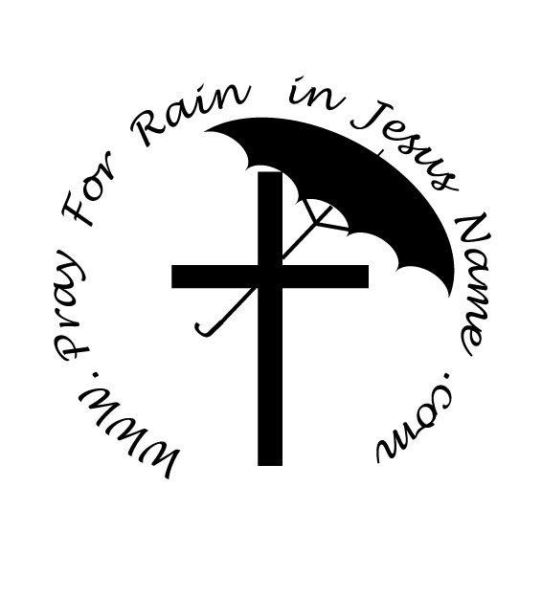

Welcome

Reality of the drought.

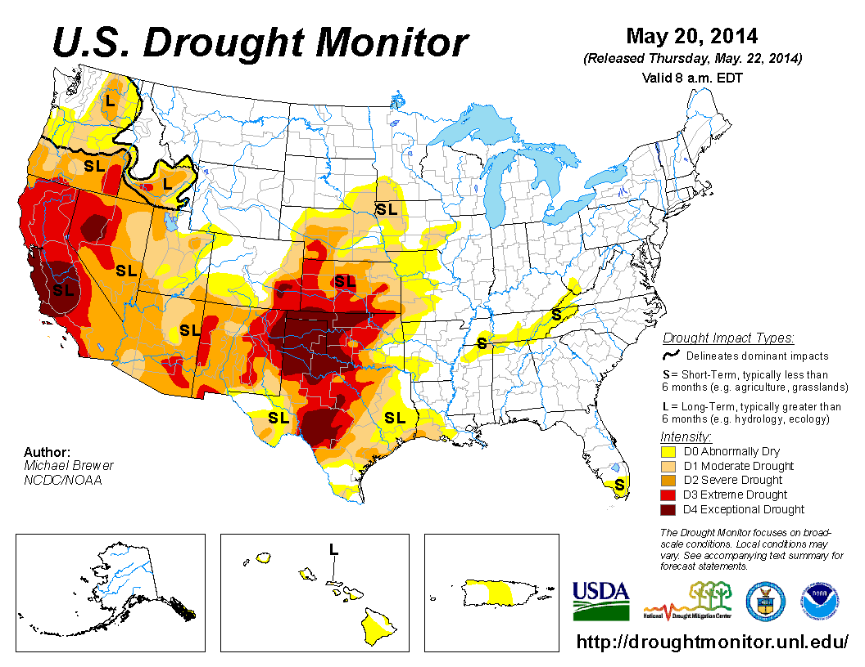

**Drought Severity**

| **Week** | **Nothing** | **D0-D4** | **D1-D4** | **D2-D4** | **D3-D4** | **D4** |
| --- | --- | --- | --- | --- | --- | --- |
| 5/20/2014 | 52.36 | 47.64 | 38.12 | 28.30 | 14.47 | 4.99 |
| 5/13/2014 | 51.21 | 48.79 | 38.08 | 28.04 | 14.00 | 4.46 |
| 5/6/2014 | 49.33 | 50.67 | 40.06 | 28.34 | 14.49 | 4.45 |
| 4/29/2014 | 51.18 | 48.82 | 38.43 | 26.76 | 12.76 | 3.88 |
| 4/22/2014 | 49.83 | 50.17 | 38.43 | 26.20 | 11.48 | 3.26 |
| 4/15/2014 | 51.54 | 48.46 | 37.88 | 25.20 | 10.11 | 2.83 |
| 4/8/2014 | 50.30 | 49.70 | 37.98 | 24.23 | 9.88 | 2.53 |
| 4/1/2014 | 47.12 | 52.88 | 38.37 | 24.12 | 9.80 | 2.18 |

**Percent Area in U.S. Drought Monitor Categories**

U.S.

Texas

| **Week** | **Nothing** | **D0-D4** | **D1-D4** | **D2-D4** | **D3-D4** | **D4** |
| --- | --- | --- | --- | --- | --- | --- |
| 5/20/2014 | 9.82 | 90.18 | 72.31 | 56.11 | 40.35 | 25.05 |
| 5/13/2014 | 8.82 | 91.18 | 73.05 | 56.10 | 39.88 | 20.73 |
| 5/6/2014 | 5.11 | 94.89 | 83.35 | 65.13 | 46.17 | 21.28 |
| 4/29/2014 | 9.88 | 90.12 | 74.47 | 52.91 | 37.86 | 17.75 |
| 4/22/2014 | 13.62 | 86.38 | 68.68 | 48.56 | 32.67 | 12.54 |
| 4/15/2014 | 17.64 | 82.36 | 65.67 | 44.14 | 28.98 | 10.31 |
| 4/8/2014 | 17.48 | 82.52 | 63.58 | 40.46 | 27.60 | 7.08 |
| 4/1/2014 | 15.40 | 84.60 | 66.80 | 42.06 | 27.36 | 4.42 |

Why pray for rain?

The earth and man are tied together.

The earth is impacted by man’s relationship with God.

Man’s relationship with God is what ties them to the earth.

The solution to the restoration of rain is spiritual, not physical.

Why in Jesus’ name?

The Biblical witness:

Acts 4: [1](http://www.studylight.org/desk/?q=ac%204:1&t1=en_nas&sr=1) As they were speaking to the people, the priests and the captain of the temple *guard* and the Sadducees came up to them, [2](http://www.studylight.org/desk/?q=ac%204:2&t1=en_nas&sr=1) being greatly disturbed because they were teaching the people and proclaiming in Jesus the resurrection from the dead. [3](http://www.studylight.org/desk/?q=ac%204:3&t1=en_nas&sr=1) And they laid hands on them and put them in jail until the next day, for it was already evening. [4](http://www.studylight.org/desk/?q=ac%204:4&t1=en_nas&sr=1) But many of those who had heard the message believed; and the number of the men came to be about five thousand. [5](http://www.studylight.org/desk/?q=ac%204:5&t1=en_nas&sr=1) On the next day, their rulers and elders and scribes were gathered together in Jerusalem; [6](http://www.studylight.org/desk/?q=ac%204:6&t1=en_nas&sr=1) and Annas the high priest *was there,* and Caiaphas and John and Alexander, and all who were of high-priestly descent. [7](http://www.studylight.org/desk/?q=ac%204:7&t1=en_nas&sr=1) When they had placed them in the center, they *began to* inquire, "By what power, or in what name, have you done this?" [8](http://www.studylight.org/desk/?q=ac%204:8&t1=en_nas&sr=1) Then Peter, filled with the Holy Spirit, said to them, "Rulers and elders of the people, [9](http://www.studylight.org/desk/?q=ac%204:9&t1=en_nas&sr=1) if we are on trial today for a benefit done to a sick man, as to how this man has been made well, [10](http://www.studylight.org/desk/?q=ac%204:10&t1=en_nas&sr=1) let it be known to all of you and to all the people of Israel, that by the name of Jesus Christ the Nazarene, whom you crucified, whom God raised from the dead—by this *name* this man stands here before you in good health. [11](http://www.studylight.org/desk/?q=ac%204:11&t1=en_nas&sr=1) "He is the stone which was rejected by you, the builders, *but* which became the chief corner *stone.* [12](http://www.studylight.org/desk/?q=ac%204:12&t1=en_nas&sr=1) "And there is salvation in no one else; for there is no other name under heaven that has been given among men by which we must be saved."

John 14: [13](http://www.studylight.org/desk/?q=joh%2014:13&t1=en_nas&sr=1) "Whatever you ask in My name, that will I do, so that the Father may be glorified in the Son. [14](http://www.studylight.org/desk/?q=joh%2014:14&t1=en_nas&sr=1) "If you ask Me anything in My name, I will do *it.* [15](http://www.studylight.org/desk/?q=joh%2014:15&t1=en_nas&sr=1) "If you love Me, you will keep My commandments.

How should we pray?

Pray for an end of the spiritual drought. If we are restored as a nation under God, the rain will come.

The first step in Revival is salvation.

What do we know about salvation?

The Second step is in sanctification.

What do we know about sanctification?

About Us

Store